Creating Web Server using Node

Node.js provides **http** module which can be used to create either HTTP client of server. Following is a bare minimum structure of HTTP server which listens at 8081 port.

Create a js file named server.js:

*File: server.js*

var http = require('http');

var fs = require('fs');

var url = require('url');

// Create a server

http.createServer( function (request, response) {

// Parse the request containing file name

var pathname = url.parse(request.url).pathname;

// Print the name of the file for which request is made.

console.log("Request for " + pathname + " received.");

// Read the requested file content from file system

fs.readFile(pathname.substr(1), function (err, data) {

if (err) {

console.log(err);

// HTTP Status: 404 : NOT FOUND

// Content Type: text/plain

response.writeHead(404, {'Content-Type': 'text/html'});

}else{

//Page found

// HTTP Status: 200 : OK

// Content Type: text/plain

response.writeHead(200, {'Content-Type': 'text/html'});

// Write the content of the file to response body

response.write(data.toString());

}

// Send the response body

response.end();

});

}).listen(8081);

// Console will print the message

console.log('Server running at http://127.0.0.1:8081/');

Next let's create following html file named index.htm in the same directory where you created server.js

*File: index.htm*

<html>

<head>

<title>Sample Page</title>

</head>

<body>

Hello World!

</body>

</html>

Now let us run the server.js to see the result:

$ node server.js

Verify the Output

Server running at http://127.0.0.1:8081/

Make a request to Node.js server

Open http://127.0.0.1:8081/index.htm in any browser and see the below result.

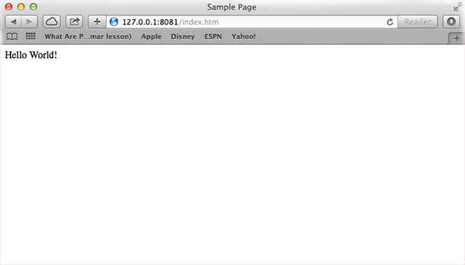

Verify the Output at server end.

Server running at http://127.0.0.1:8081/

Request for /index.htm received.

Creating Web client using Node

A web client can be created using **http** module. Let's check the following example.

Create a js file named client.js:

*File: client.js*

var http = require('http');

// Options to be used by request

var options = {

host: 'localhost',

port: '8081',

path: '/index.htm'

};

// Callback function is used to deal with response

var callback = function(response){

// Continuously update stream with data

var body = '';

response.on('data', function(data) {

body += data;

});

response.on('end', function() {

// Data received completely.

console.log(body);

});

}

// Make a request to the server

var req = http.request(options, callback);

req.end();

Now run the client.js from a different command terminal other than server.js to see the result:

$ node client.js

Verify the Output.

<html>

<head>

<title>Sample Page</title>

</head>

<body>

Hello World!

</body>

</html>

Verify the Output at server end.

Server running at http://127.0.0.1:8081/

Request for /index.htm received.